- **Project Name:** Giveth

- **Team Name:** Giveth

- **Payment Address:** 0x4D9339dd97db55e3B9bCBE65dE39fF9c04d1C2cd (giv.eth)

- **[Level]:** 🌲-Tree

## Project Overview :page_facing_up:

**Valuable Links**

Website: <https://giveth.io/>

Discord: [Discord](https://discord.gg/Nj9zM9Dq)

Twitter: <https://twitter.com/Givethio>

Youtube: [The Biggest Web3 Opportunity That No One Is Talking About](https://www.youtube.com/watch?v=DBGoX7DON54&ab_channel=EthereumFoundation)

Presentations

Deck: [Giveth Deck_2022.pdf - Google Drive](https://bit.ly/3TdCqiq)

### Overview

**- If the name of your project is not descriptive, a tag line (one sentence summary).**

Giveth is using blockchain to reward and empower those who give to projects, to society, and to the world!

**- A brief description of your project.**

Giveth is incredibly aligned with Radicle in using web3 to evolve our coordination around Public Goods! Our community is focused on Building the Future of Giving using blockchain technology. Our intention is to support and reward the funding of public goods by creating open, transparent and free access to the revolutionary funding opportunities available within the Ethereum ecosystem.

We are thrilled to partner up with Radicle to use Radicle drips to continuously stream funds from donors to nonprofits & other public goods projects on Giveth.io.. On our DApp, 100% of donations go directly to the project and donors to verified projects are rewarded with GIVbacks. Making a project to raise funds on [giveth.io](http://giveth.io) is simple and permissionless, however projects to gain access to additional platform benefits, they must apply for "Project Verification" - a system designed to vett projects and verify if they are providing public good. Verified projects are part of our "GIVbacks program" where, as always, 100% of donations do directly to the projects, and donor gets the added benefit of being rewarded with GIV.

The GIVeconomy is what really sets us apart from just being another donation application, below is a quick run-through of the major pieces of our ecosystem.

GIV - A transferable ERC-20 token that lies at the heart of the future of giving (native to Mainnet). (LAUNCHED  )

GIVbacks - The entry point to the GIVeconomy. Donors to verified public goods projects get GIV tokens in return. This flips the script on tax deductible donation, creating a decentralized and borderless way of incentivizing donations. (LAUNCHED  )

GIVgarden - Platform for decentralized governance over funding proposals. GIV holders are able to propose and vote on how to allocate funds from the Giveth community treasury using Conviction Voting. (LAUNCHED  )

rGIV DAO - This is a unique reputation DAO where contributors who have been actively participating in our community for 3 months or more are eligible to participate. This DAO mostly handles the day-to-day operations and stewards the GIVeconomy smart contracts. (LAUNCHED  )

GIVpower - Donors can lock their GIV tokens for GIVpower and use them to boost/curate projects on the platform. Projects with more GIVpower are ranked higher and in turn, their donors are rewarded with more GIVbacks. Locking is live, boosting is fully developed and being tested now, it should roll out in an upcoming release (LAUNCHING )

GIVfi - Latent donations on the platform can be used to generate a low-risk yield while waiting to be disbursed. This yield is to support the Giveth DAO, and a portion is given to the projects themselves (“GIVsavings”), enabling nonprofits to have something like a defi saving account . (PHASED ROLL OUT - 2023)

GIVmatching - Top-ranked public goods and for-good projects on the platform will have the opportunity to have their donations matched via a collectively funded matching pool. We are collecting funds for the matching pool at donation.eth and plan to work with the (Gitcoin) Grants 2.0 system when it is released (Q2 2023).

GURVES - The holy grail of public goods funding. Giveth projects can evolve into DAOs with their own micro-economies collateralized by GIV in a bonding curve. This is still very much in the research phase in partnership with Commons Stack, but is the Giveth endgame, turning the donation platform into an investment platform. (TBA)

We also have NFT projects, several integrations, partnerships, and community projects in the pipeline.

**- An indication of how your project relates to / integrates into Radicle.**

By integrating Radicle Drips with Giveth, we would launch recurring donations as streams. Donors interested in the projects can opt-in to allocate a Drip to the projects they want to support. If the project is verified, donors will get rewarded with GIV and POAPs for allocating these Drips via our [GIVbacks program](https://medium.com/giveth/what-if-giving-gave-back-using-web3-to-evolve-philanthropy-a8500b7636ce).

With this project, Giveth will enable public goods and nonprofits to benefit from Drips while rewarding users with GIVbacks. Giveth would be offering a direct incentive to donors/impact investors who choose to use Drips for their donations.

We are requesting 60,000 USD in this grant proposal to integrate Radicle Drips into our Giveth economy. The detailed project roadmap is outlined in the deliverables and milestones further on.

With our partnership, we are cementing the building blocks of collaboration between two mission-aligned organizations. The goal is to establish a long-lasting relationship that will benefit both the ecosystem and the DAOs in these 3 levels of partnership:

**Social interoperability** - Both projects will support each other in respective social media channels, co-sponsor events, and undertake co-marketing activities to promote each other's visions.

**Product/Technology interoperability** - Radicle drips would open doors to many more possibilities for diversifying the usability in our GIVeconomy universe.

1. Adding recurring donations through the Drips protocol to the Giveth main product, Donations.

2. Launching a Radicle community in Giveth

3. Expanding GIVstream functionality with a deeper protocol integration

4. Exploring ways to empower GIVpower.

**Governance Rights interoperability** - Giveth is a strong supporter of DAO-to-DAO collaborations which is why we have a very diversified treasury with the projects whom our mission align. As a future next step to strengthen this partnership even further, we think both DAOs would benefit from a more diverse voter base, through a GIV <> RAD token swap (to be described in detail in a seperate proposal).

**Please describe why you are applying for this grant.**

We would like to integrate Radical Drips as a new way of giving on giveth.io. Allowing donors on the platform to create donation streams to projects they want to support. Radicle drips provide 3 distinctive benefits to donors on Giveth:

1. Streamers can end a stream prematurely whenever they choose.
2. There is no process of wrapping a token to set up a stream.
3. A donor doesn’t need to have all of the funds up front to create a stream.

We estimate to allocate minimum 3 months of planning, design, development and testing for integrating Radicle drips into our streams. The discussions and planning between both teams has already kickstarted and we are excited to start the development work. This grant would certainly support us to continue with the development and milestones outlined below.

Considering the noted interoperabilties and how Radicle can play a substantial role in our current and future roadmap, we’d love to see Radicle’s support in this project.

We expect to deploy the first rollout within 2-3 months after this grant passes.

We would also explore future opportunities using radical drips in upcoming roadmap features. GIVfi, a yield-earning strategy through donations, would be a great candidate to expand Radicle features into. This feature would deploy idle donation funds to generate additional revenue for Giveth and the public goods. GIVfi is still in a research phase and we certainly explore the possibilities of further integrations with Radicle as we progress in our roadmap.

## Deliverables :nut_and_bolt:

**Milestone 1:** Analyze and use case designs/mockups

Specification:

1. Simulating and analyzing the use case
2. Finalize the specifications
3. Mockup/blueprint of the user journey and the UX
4. Software analysis and integration flow
5. Backend design and creating an MVP design spec
6. Review technical boundaries with UX
7. Prototyping and review
8. Create an MVP design spec

**Estimated Duration:** ~~21 days~~

**FTE:**

1 project manager ## days

1 Business analyst ## days

1 Designer ## days

**Total cost:**

**Milestone 2:** MVP implementation

Specification:

1. Backend implementation
2. Front-end implementation
3. Integration of front-end with backend and review the edge-cases
4. Unit Testing
5. Test final integration with Drips (integration-test)
6. User Acceptance Testing

**Estimated Duration:** 30 days

**FTE:**

1 project manager ## days

1 back-end dev ## days

1 front-end dev ## days

**Total cost:**

**Milestone 3:** Test Pilot

Specification:

1. Outlining all test scenarios
2. Finding a project partner for piloting
3. Launch with a real user and donors
4. Outlining the feedbacks
5. Plan to implement feedbacks

**Estimated Duration:** 15 days

**FTE:**

1 project manager ## days

1 UX researcher ## days

1 back-end dev ## days

1 front-end dev ## days

**Total cost:**

**Milestone 4:** Implementation of side features and preparation for launch!

Specification:

1. Analysis of feedback and identifying issues
2. Implementing the suggested feedback
3. Testing the whole new flow with real users

**Estimated Duration:** 7 days

**FTE:**

1 project manager ## days

1 Business analyst ## days

1 UX researcher ## days

1 back-end dev ## days

1 front-end dev ## days

**Total cost:**

**Milestone 5 :** Go to market/ Launch Communications

Specification:

1. **Week 1** - Partnership announcement post
2. **Week 1** - Social Media - Share on Discord - Post on Discourse
3. **Week 3** - Newsletter w/Partnership announcement
4. **Week 5** - Partner Spotlight, ie.: Twitter spaces on Radicle account sharing latest details on GIVPower w/ our community.
5. **Week 7** - Partner use case blog post and/or TW thread
6. **Week 9** - Co-education demo/Tutorial repos (on radicle or Youtube)

**Estimated Duration:** 65 days

**FTE:**

1 project manager ## days

2 community coordinator ## days

2 communications/media members ## days

**Total cost:**

## Future Plans

<https://docs.google.com/spreadsheets/d/1SjywRWjUB1XYy4CaluUJ7Luh0zA7dLatiQrJ5ZFd9o0/edit#gid=2024716496>

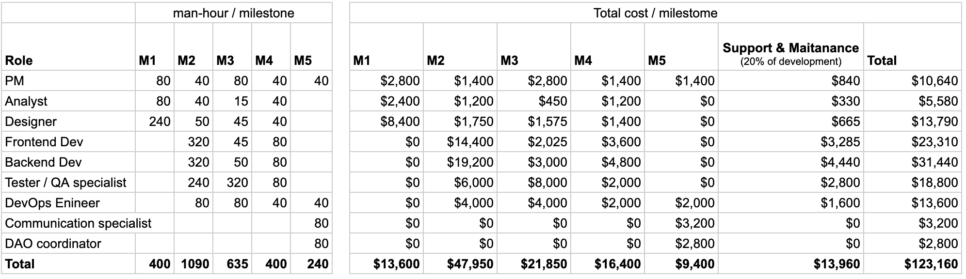

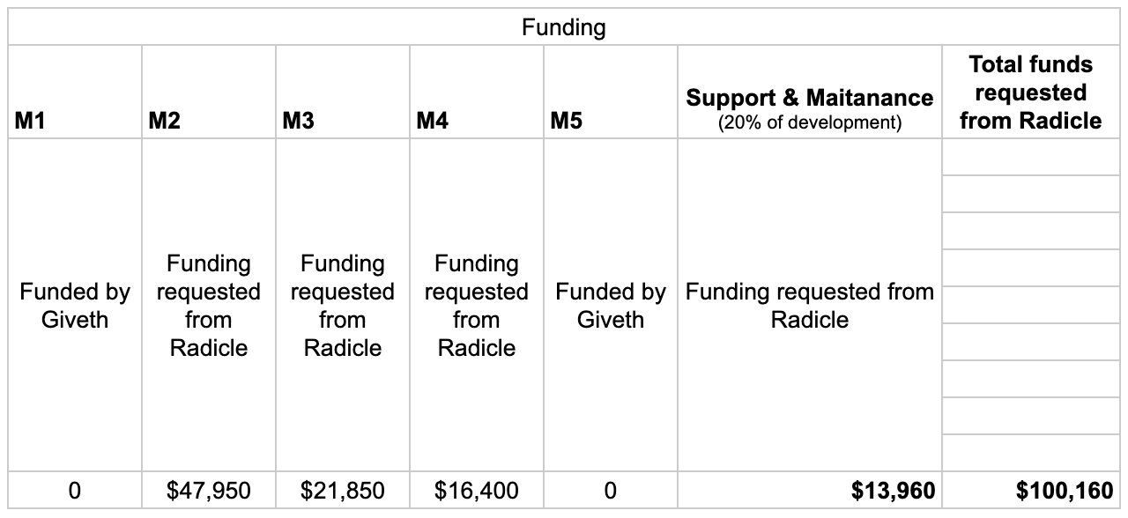

**How you intend to use, enhance, promote and support your project in the short term**

- Adding the new chains

- Adding new tokens.

- Using Radicle for splitting to a Cart of projects

- Usnig Radicle for splitting default donations

## Team :busts_in_silhouette:

### Team members

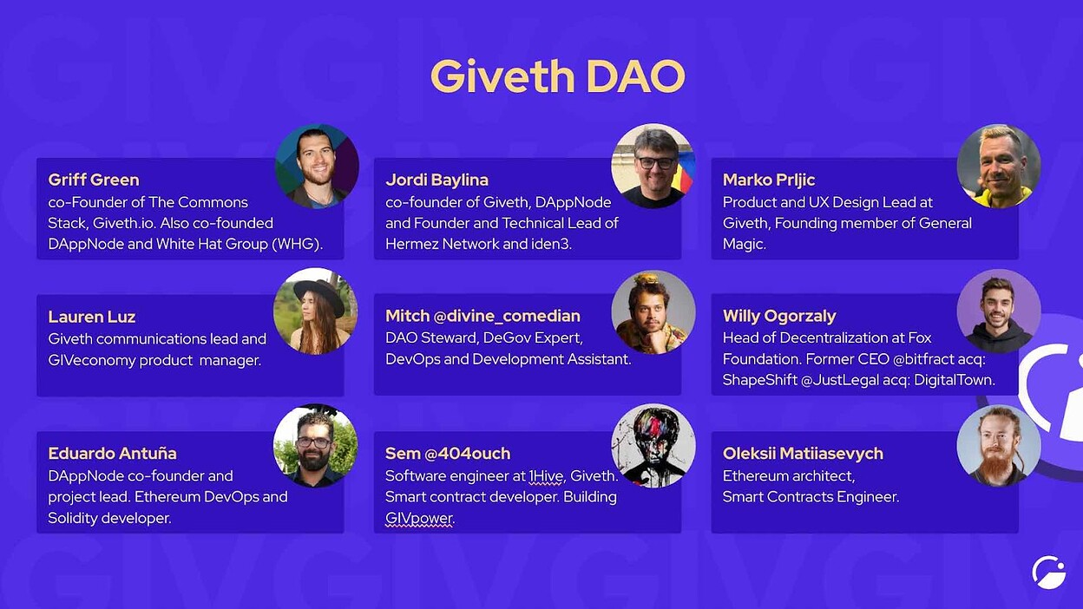

- Name of team leader

- Names of team members

### Contact

- **Contact Name:**

- **Contact Email:**

- **Website:**

### Team's experience

Please describe the team's relevant experience.

If your project involves development work, please single out a few interesting projects or contributions made by team members in the past.

For research-related grants, references to past publications and projects in a related domain are helpful.

Our team has been in the public goods space since 2016 and have been a major contributor to many know projects:

TheDAO

White Hat Group

[Aragon](https://aragon.org/)

[Status](https://status.im/)

[iden3](https://iden3.io/)

[Polygon Hermez](https://polygon.technology/solutions/polygon-hermez/)

[1hive](https://1hive.org/)

[xDai - now Gnosis Chain](https://www.gnosischain.com/)

[Commons Stack](https://commonsstack.org/)

[Token Engineering Commons](https://tecommons.org/)

[brightID](https://www.brightid.org/)

[dappnode](https://www.dappnode.io/)

[General Magic](https://www.generalmagic.io/)

If anyone on your team has applied for a grant at Radicle or elsewhere, please share info on that here.

### Team Code Repos

- https://github.com/Giveth

- https://github.com/<your_organisation>/<project_1>

- https://github.com/<your_organisation>/<project_2>

Please also provide the GitHub accounts of all team members. If they contain no activity, references to projects/repos hosted elsewhere are also fine.

- https://github.com/<team_member_1>

- https://github.com/<team_member_2>

### Team LinkedIn Profiles (if available)

- https://www.linkedin.com/<person_1>

- https://www.linkedin.com/<person_2>

## Project Description :page_facing_up:

- The team's long-term plans and intentions in relation to it. In other words, how will it be made sustainable?

>️ ❗*This is a good place to share how you might like to get more grant funding for future work*

## Additional Information :heavy_plus_sign:

**How did you hear about the Grants Program?** Medium / Twitter / Discord / Announcement by another team / personal recommendation / etc.

Here you can also add any additional information that you think is relevant to this application but isn't part of it already, such as:

- Work you have already done.

- If there are any other teams who have already contributed (financially) to the project.

- Previous grants you may have applied for.

—------------------------------

Useful links:

<https://radicle.community/t/discussion-radicle-grants-program-continuation/3019>

<https://radicle.community/t/grant-application-dogfooding-the-proposal-inverter/2806/3>

<https://radicle.community/c/grants/24>

<https://radicle.community/t/fileverse-arxaiv-grant-application/2985>

<https://radicle.community/t/grant-application-dao-blocks/3047>

<https://radicle.community/t/grant-application-daostar-one/2753>

<https://raw.githubusercontent.com/radicle-dev/radicle-grants/main/grants/applications/template.md>

<https://github.com/radicle-dev/radicle-grants/blob/main/grants/applications/template.md>